Home Page

Hero Section

4-Color System™
A Visual Framework for Reading Market Behavior
Understand liquidity shifts, execution context, and structural pressure
through a simplified 4-Color price model.

LITE — OFFICIAL ELEMENTS
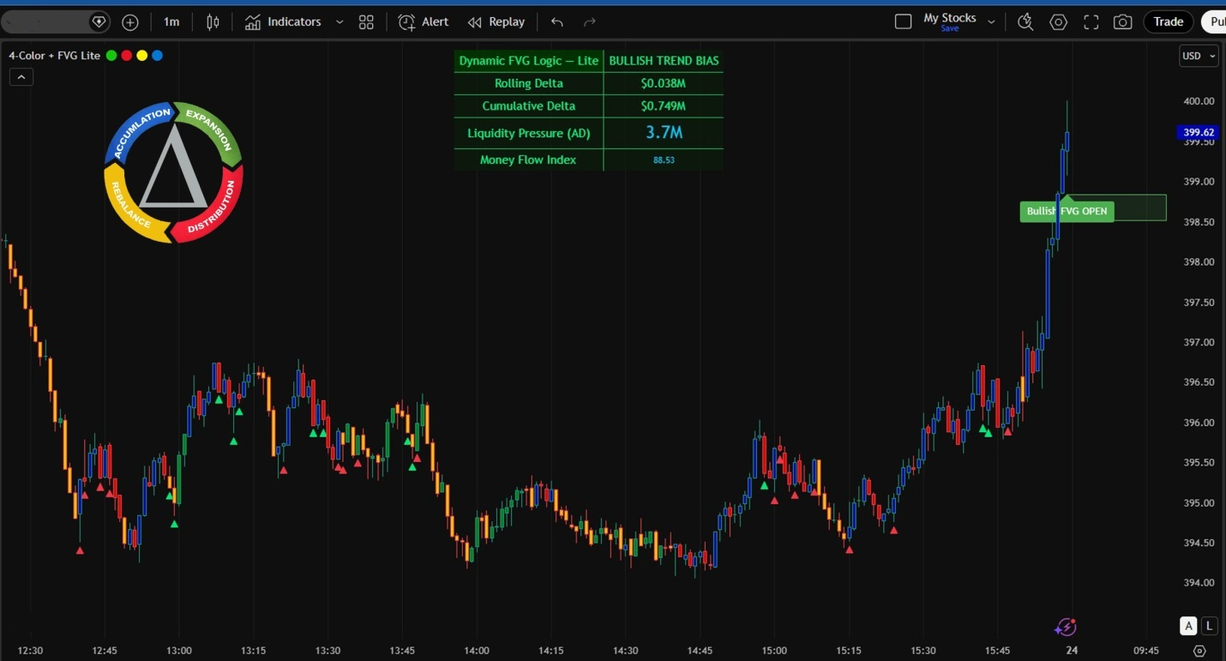

Powered by 4Color Liquidity States
The 4-Color System™ turns complex price behavior into a readable structure.
Available to all TradingView users.

Lite Version – Free Access
https://www.tradingview.com/script/dWscMbbP-Four-Color-Order-Flow-System/
Join Pro Waitlist
Apply for Elite

Built for traders who care about context, control, and survival — not alerts.
Purpose: Learn to read control before imbalance.
The Power of 4-Color System
Price shows where.
4-Color shows who.
INTRO – Lite Version
Dynamic FVG Logic – Lite (4-Color Based) is a price behavior reading system, not a direction-guessing indicator.
It reads who is in control through candle color behavior.
It helps you:
See quickly who’s driving the market
Know whether price is real movement or a trap
Avoid trading when control is unclear
No BUY / SELL
No entry signals
Observation only – real-time market state
4-COLOR CANDLES – How to Read Them
 RED – Active Selling Pressure
Sellers are in control
Price moves fast and decisively
Often appears after breakdowns, distribution, or traps
 Multiple Reds = don’t bottom-fish
 GREEN – Active Buying Pressure
Buyers are stepping in for real
Price is being pushed, not dragged
Used to judge whether an up-move has real force
 Green without follow-through = likely technical bounce
 BLUE – Swing High / Resistance Zone
Price is entering a previously controlled area
Common behaviors:
Slowing down
Rejection
Short accumulation
 Not a buy zone — observation zone
 YELLOW – Swing Low / Liquidity
Liquidity sweep area
False breaks are common
Often the start of a reaction
 Not a safe bottom — force-testing zone

Join Pro Waitlist link to Pro page
Apply for Elite, link to Elite page

